Október 2012
EUROPEAN NETWORK CULTURE and management

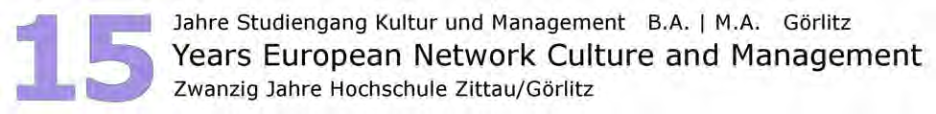

Starting in October 2012, we will offer for the whole academic year lectures in English language following our university's principles: Small Groups – High Interaction – Fair Quality.
Europe is a multilingual continent, it can not be reduced to one language. Therefore our students, our professors and our international colleagues would be happy to welcome students from abroad in German and in Polish, in Russian and in Italian, in English and even in Japanese, and quite some other languages. Come and spend a week with us at the wonderful city of Görlitz. Görlitz is the German city with the highest number of sun shine hours. With its 4,000 classified monuments, experts call it the most beautiful city of Germany. The twin towns Zgorzelec and Görlitz (together almost 100,000 inhabitants) are unique for their cross boarder project as ‘Towns of Europe’. Prices meet students’ needs. The region Upper Lusatia is rich for its leisure attractions, natural beauties and cultural diversity. Dresden (100 km), Prague (140 km), Wrocław (160 km), Berlin (190 km), Leipzig (200 km), Krakow (430 km) are within a weekend’s reach. Starting in the winter term 2012/13 we are offering to students who do not speak German a full semester English Language Program in which you can obtain 30 credit points. Small groups – high interaction – fair quality. The program will include a German Language Unit (5 cp) and elective modules from different faculties you can freely choose from (other 25 cp).

Please register till 1 June 2012 bei Institute of applied ethics - Doc. I. Szaniszló (vladimir.szaniszlo@ku.sk)

Prof. Dr. phil. Dr. habil. Matthias Theodor Vogt, Dorothea Boutin, Elisa LiehmannHochschule Zittau/Görlitz, Fakultät Management und Kulturwissenschaften i.G.Klingewalde 40, D-02828 Görlitz

